**Mario Lavista Camacho (Mexico City, 1943-)**

Ana R. Alonso-Minutti

Mexican composer, pianist, intellectual, editor, and teacher, Mario Lavista is regarded as a central figure in the contemporary music scene of his native country Mexico. A prolific composer of orchestral, stage, chamber, solo, and electronic pieces, his oeuvre is characterized by its intersections with the other arts. His music shows an integration of modernist avant-garde trends of both European and American music, while adopting compositional techniques of diverse historical periods of Western art traditions. He has maintained an active performance career, especially in collective improvisations using prepared piano.

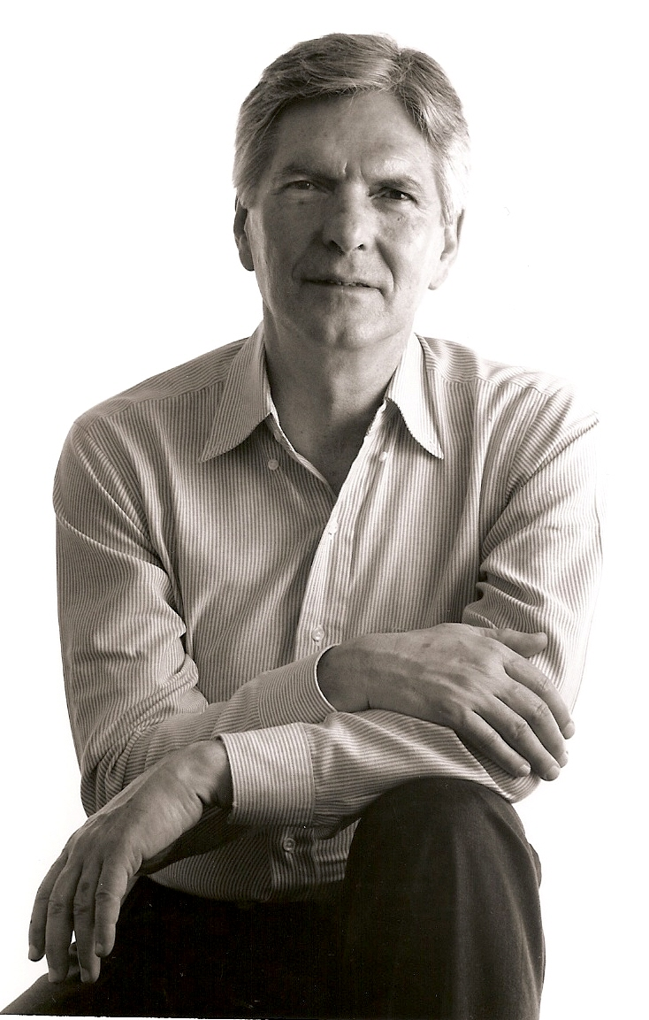

Mario Lavista, 2009. (Photo courtesy of composer).

Lavista’s role as intellectual has been shaped mainly through the series of lecture-recitals he regularly organizes as member of El Colegio Nacional—a prestigious government-funded institution intended to foster cultural and intellectual activities of an intellectual elite. Moreover, he is founder and director of one of the most renowned music journals in Mexico, *Pauta: Cuadernos de Teoría y Crítica Musical,* which promotes multidisciplinary dialogues, especially among writers, painters and musicians, and has a strong emphasis on contemporary music. Lavista has been teaching at the Conservatorio Nacional since 1970, where his role as educator and mentor has been particularly relevant for “practically all Mexican composers that are younger than he is,” according to Luis Jaime Cortez.[1]

**Overview**

Mario Lavista began his piano studies as a child and enrolled at the Taller de Composición of the Conservatorio Nacional de Música in 1963 under the guidance of Carlos Chávez, Héctor Quintanar, and Rodolfo Halffter. He was granted a scholarship from the French government to study at the Schola Cantorum in Paris from 1967 to 1969 under Jean Etienne Marie. During that season he attended courses taught by Henri Pusseur, Nadia Boulanger, Christoph Caskel, and Karlheinz Stockhausen.

Upon his return to Mexico, together with Nicolás Echevarría, Fernando Baena (who was later substituted by Juan Herrejón) and Antero Chávez, Lavista founded Quanta—a collective improvisation group in 1970. Their improvisations usually involved the use of Julián Carrillo’s microtonal instruments (especially harps), basic amplification applied to acoustic instruments, electric guitars, and a variety of percussion instruments. During two years Quanta had a vigorous performance schedule collaborating with dance and theater companies. These experimental sessions were crucial in forming a public for avant-garde happenings in Mexico City.

Lavista’s interest in sound manipulation through electronic means led him to work on the recently created Laboratory of Electronic Music of the Conservatorio Nacional de Música, and at the electronic music studio of radio and television in Tokyo, Japan (NHK) in 1972. From 1974 to 1976 Lavista was head of the Music Department of the Dirección de Difusión Cultural of the Universidad Nacional Autónoma de México, and in 1982 he founded the journal *Pauta*, which is issued four times a year, and has served as its chief editor ever since.

Throughout the 1970s Lavista’s activities as a pianist were numerous. Along with renowned performers such as Jorge Velazco, Federico Ibarra and Marielena Arizpe, he premiered works by Erik Satie, Karlheinz Stockhausen, John Cage, Manuel Enríquez, Oliver Messiaen, Gerhard Muench, Rodolfo Halffter, among others.

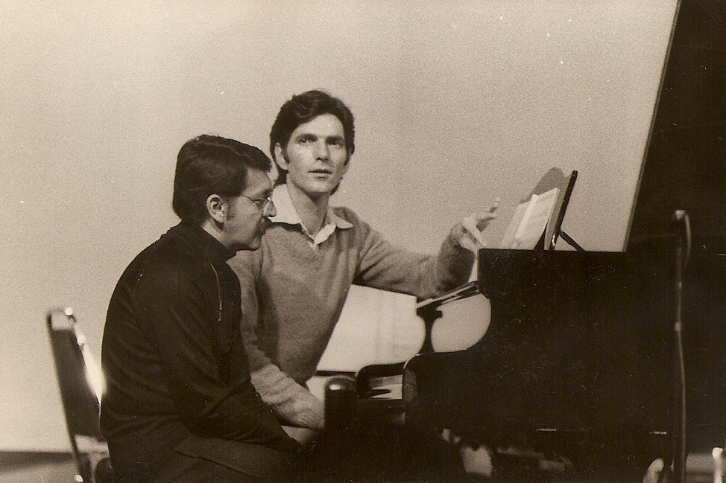

From left to right: Federico Ibarra and Mario Lavista, 1979. (Photo courtesy of Lavista)

In 1987 he became a member in the Academia de las Artes, and received a Guggenheim Fellowship for his first and only opera *Aura*, based on the short story by Carlos Fuentes. Moreover he received the Premio Nacional de Ciencias y Artes and the Medalla Mozart in 1991, an honorable mention from the Sistema Nacional de Creadores del Fondo para la cultura y las Artes in 1993, and membership in the prestigious El Colegio Nacional since 1998.

Lavista’s role as a teacher and lecturer has extended from his native country where he has been a professor at the Conservatorio Nacional since 1970, to the Americas and Europe. He has been guest lecturer at Indiana University, University of Chicago, Cornell University, University of California Davis, University of California San Diego, University of California Santa Barbara, and University of North Texas, among others. He has received commissions from international festivals and his works are frequently performed by some of the most distinguished chamber and orchestral groups, both in Mexico and abroad.

**Works**

Lavista’s early works show a predilection for serial techniques and the use of literary texts (*Monólogo, Dos canciones, Homenaje a Beckett*). During his time in Europe he explored sound resources by incorporating short wave radios (*Divertimento*, 1968), and alarm clocks (*Kronos*, 1969). In his first string quartet (*Diacronía*, 1969), he began to incorporate certain aspects of indeterminacy and to explore the intervallic possibilities of two perfect fifths linked by a tritone—a sonority that permeated much of his work for the following decades.

Upon his return to Mexico, and parallel to his involvement with Quanta, Lavista wrote a series of pieces with open forms such as *Pieza para un(a) pianista y un piano* (1970), *Game* (1971), and *Continuo* (1971). In 1973 Lavista conceived, in conjunction with artist Arnaldo Coen, the graphic score *Cluster*, for piano. A few years later, Coen and Lavista collaborated in yet another graphic score, *Jaula*, a paper sculpture of 16 layers of concentric cubes, which has achieved a central place in the history of conceptual interdisciplinary Mexican art.

After reaching this level of abstraction, Lavista returned to writing atonal music using conventional notation and incorporating epigraphs in multiple scores (*Quotations, Lyhann, Canto del alba, Simurg*, among others). The epigraphs are chosen from a wide variety of sources: ancient Chinese poets from the Tang Dynasty, 17th-century Spanish poet Francisco de Quevedo, 20th-century American writer Ezra Pound, and many others. The epigraphs reveal not only the composer’s literary taste, but most importantly, they allow for a rich intertextual interplay between music and text. At the end of the 1970s and throughout the 1980s, Lavista explored unusual timbre possibilities by the use of extended techniques for traditional instruments and completed a series of solo and chamber pieces done in close collaboration with performers such as flutists Marialena Arizpe (*Tríptico*), bassist Bertram Turetzky (*Dusk*), oboist Leonora Saavedra (*Marsias*), and the string quartet El Cuarteto Latinoamericano (*Reflejos de la noche*), among others. Most of these pieces show clear pitch centricities and the predominant use of particular intervallic explorations.

Since the 1980s Lavista has approached religious genres in a series of compositions such as *Lamento a la muerte de Raúl Lavista* (1981), and *Responsorio in memoriam Rodolfo Halffter* (1988), where he uses Medieval and Renaissance procedures, such as the symbolic use of certain intervals, canonic permutations, and isorhythm, most evident in the *Missa ad Consolationis Dominam Nostram* (1994-95), a central work in his oeuvre. Even though Lavista is not affiliated with a particular religion, he has continued to explore Christian-Catholic religious genres in works such as *Tropo para Sor Juana* (1995), *Mater dolorosa* (2000), *Stabat Mater* (2005), and *Salmo* (2006-07), among others.

Lavista has written a number of scores for television and film. He has written music for numerous documentaries and shows commissioned by Televisa. Since the 1970s Lavista has closely collaborated with director Nicolás Echevarría for a series of film scores, of which, *Judea, Semana Santa entre los coras* (1973), is the first Mexican film using electronic music. He continued to write scores for Echevarría’s movies in subsequent occasions, *María Sabina, mujer espíritu* (1978), *Niño Fidencio* (1982), *Cabeza de vaca* (1990), and *Vivir mata* (2002).

Currently Lavista is one of the most respected figures in the intellectual-artistic scene in Mexico City. As a member of El Colegio Nacional he organizes annual series of lecture-recitals at which he presents contemporary music from Mexico and abroad performed by the most renowned chamber groups in the country, and occasionally invites performers from abroad. He has written an extensive number of short essays, most of which are published in the *Memorias* of El Colegio Nacional and in *Pauta*.

**Selected Bibliography**

Alonso-Minutti, A.R. (2012) “Contrapunto a 4: Una mirada a la trayectoria de Mario Lavista desde sus cuartetos de cuerda.” *Pauta: Cuadernos de teoría y crítica musical* 121. (A brief study of Lavista’s six string quartets).

Alonso-Minutti, A.R. (2008) “Espacios imaginarios: Aspectos de colaboración en dos obras de Mario Lavista,” *Discanto: Ensayos de investigación musical. Tomo II*, ed. by Ricardo Miranda and Luisa Vilar-Payá. Xalapa, Veracruz: Universidad Veracruzana. (An interpretive study of the collaboration process of two of Lavista’s chamber works: *Marsias*, where he collaborated with oboist Leonora Saavedra, and *Reflejos de la noche*, a collaboration with El Cuarteto Latinoamericano).

Alonso-Minutti, A.R. (2008) “Permuting Cage,” *Brújula* vol. 6. (A short article about *Jaula*, an interdisciplinary collaboration between Lavista and Arnaldo Coen in homage of John Cage.)

Alonso-Minutti, A.R. (2008) “Resonances of Sound, Text, and Image in the Music of Mario Lavista,” diss., University of California, Davis. (The most extensive study about Lavista’s work with a discussion of representative compositions in his oeuvre.)

Carredano, C. (2000) “Mario Lavista” *Diccionario de la música española e hispanoamericana* 6: 803-12. (A lengthy encyclopedia entry which includes biographical information, analysis of relevant works and a catalog of works up to 1999.)

Cortez, L.J. (1988) *Mario Lavista.* *Textos en torno a la música*, Mexico City: CENIDIM. (A collection of short articles by Lavista and about Lavista up to 1985).

Delgado, E. (1993) “El lenguaje musical de Aura,” Heterofonía, 108, I-V-1995, 54-51. (An analytical study of Lavista’s only opera.)

Escuer, A. (1995) “The Interpretation of Selected Extended Techniques in Flute Solo Compositions by Mexican Composers: An Analysis and Performance Recommendations,” diss., New York University. (Includes a discussion of Lavista’s works for solo flute from the late 1970s early 1980s.)

García Bonilla, R. (2001) *Visiones sonoras. Entrevistas con compositores, solistas y directores,* Mexico City: Siglo Veintiuno. (Includes an extensive interview with the composer about his compositions using religious genres.)

Plana, B. “El virtuosismo instrumental en la música de Mario Lavista,” *Huellas… Búsquedas en Artes y Diseño* 5 (2006): 41-52. (Analytical and performance remarks for Lavista’s pieces for solo flute.)

Vázquez, H. (2009) *Cuaderno de viaje: un possible itinerario analítico en torno a Simurg y Ficciones de Mario Lavista*, Mexico City: CONACULTA. (An extensive analytical study on the relationship between these two works.)

**Website**

Lavista’s profile in El Colegio Nacional’s website:

<http://www.colegionacional.org.mx/SACSCMS/XStatic/colegionacional/template/content.aspx?mi=126&se=vida&te=detallemiembro>

1. Luis Jaime Cortez, ed. *Mario Lavista. Textos en torno a la música* (México DF: CENIDIM, 1988), 14.